Displaying Footer 1.jpg

**AgroDataHub Application**

**Author – Dipak Suryawanshi, Karan Nagpure, Mitali Mahalle, Rutik Wankhade, Sahil Patre, Saloni Jawade, Muskan Ahmad**

***Abstract* –** 

*AgroDataHub is a mobile application aimed at revolutionizing agricultural data management and knowledge sharing. Developed with modern technologies, the application provides farmers with a user-friendly platform to input and access crucial farm-related information. Leveraging robust databases, AgroDataHub ensures secure storage and retrieval of data, empowering farmers to make informed decisions about crop management and production optimization.*

*Additionally, the application facilitates collaboration and community engagement, offering valuable insights and resources to enhance productivity and sustainability in the agricultural sector.*

**Introduction:**

In the realm of agriculture, effective data management and information sharing are paramount for fostering productivity, sustainability, and innovation. Recognizing the critical role of technology in addressing these needs, the AgroDataHub project emerges as a transformative solution poised to revolutionize agricultural practices. AgroDataHub aims to empower farmers by providing them with a comprehensive platform to manage farm-related information efficiently.

**Motivation:**

The platform fosters collaboration and knowledge sharing among farming communities, driving collective learning and innovation. Through the AgroDataHub project, we aspire to usher in a new era of agricultural development, one where technology serves as a catalyst for growth, resilience, and sustainability in farming communities.

**Objective:**

The following are the objectives of my research work:

# Facilitate Knowledge Sharing

# Empower Farmers with Information

# Centralized Data Repository

# Decision-Making for Government

**Proposed Methodology:**

Gather a diverse dataset of illegitimate and spoofing resources present on the internet.

1) Needs Assessment and Planning

2) Feedback and Iteration:

3) Collecting and Analyzation of the Data of farmer 4) Collect Feedback

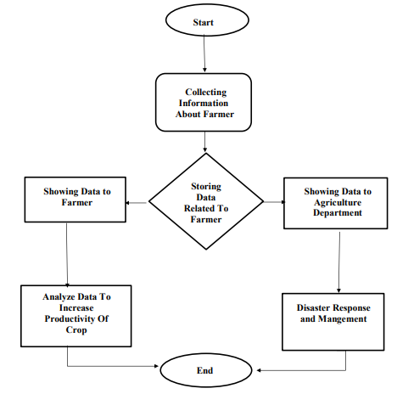

**Fig. 1. Methodology of the proposed scheme**

**Implementation & Results:**

1. Implementation of Features: Develop the frontend of the AgroDataHub ensuring a user-friendly interface and seamless navigation between different screens.
2. Integration Testing: Implement unit tests, integration tests, and end-to-end tests to validate the functionality and behavior of frontend and backend components data storage, and interaction with external APIs.
3. End-to-End Testing: End-to-end testing evaluates the entire functionality of the application from the farmer perspective, simulating real-world usage scenarios.

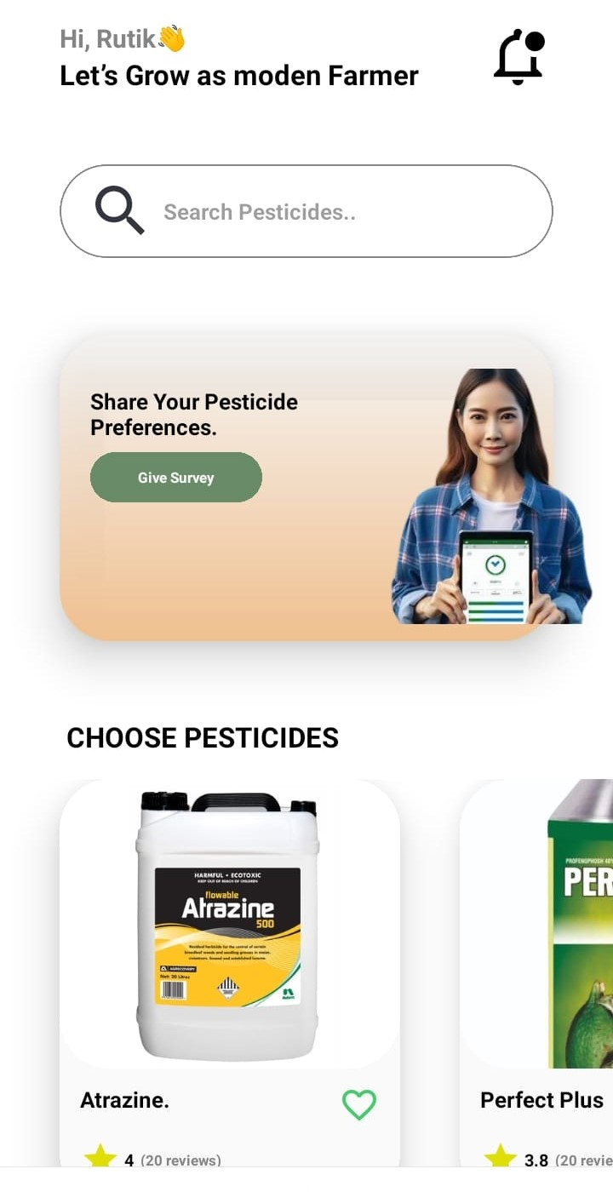 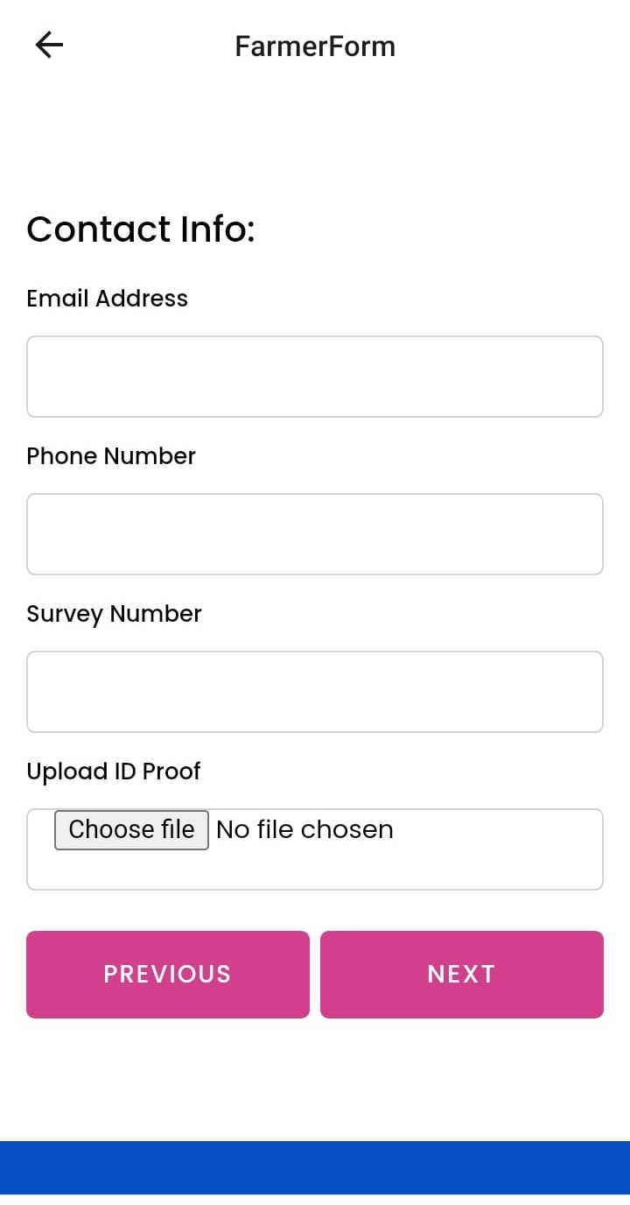

**Fig: 5.1.1 Front Page of App Fig: 5.1.2 Farmers Survey Form**

**Conclusion:**

In conclusion, The development of the AgroDataHub application represents a significant milestone in the realm of agricultural technology, aiming to revolutionize farm data management, knowledge sharing, and decision-making processes. Through the utilization of modern technologies such as React Native for frontend development, Firebase and web3api for backend support, and Expo Go application for local testing and deployment, the AgroDataHub application has been successfully implemented to address the diverse needs .

